­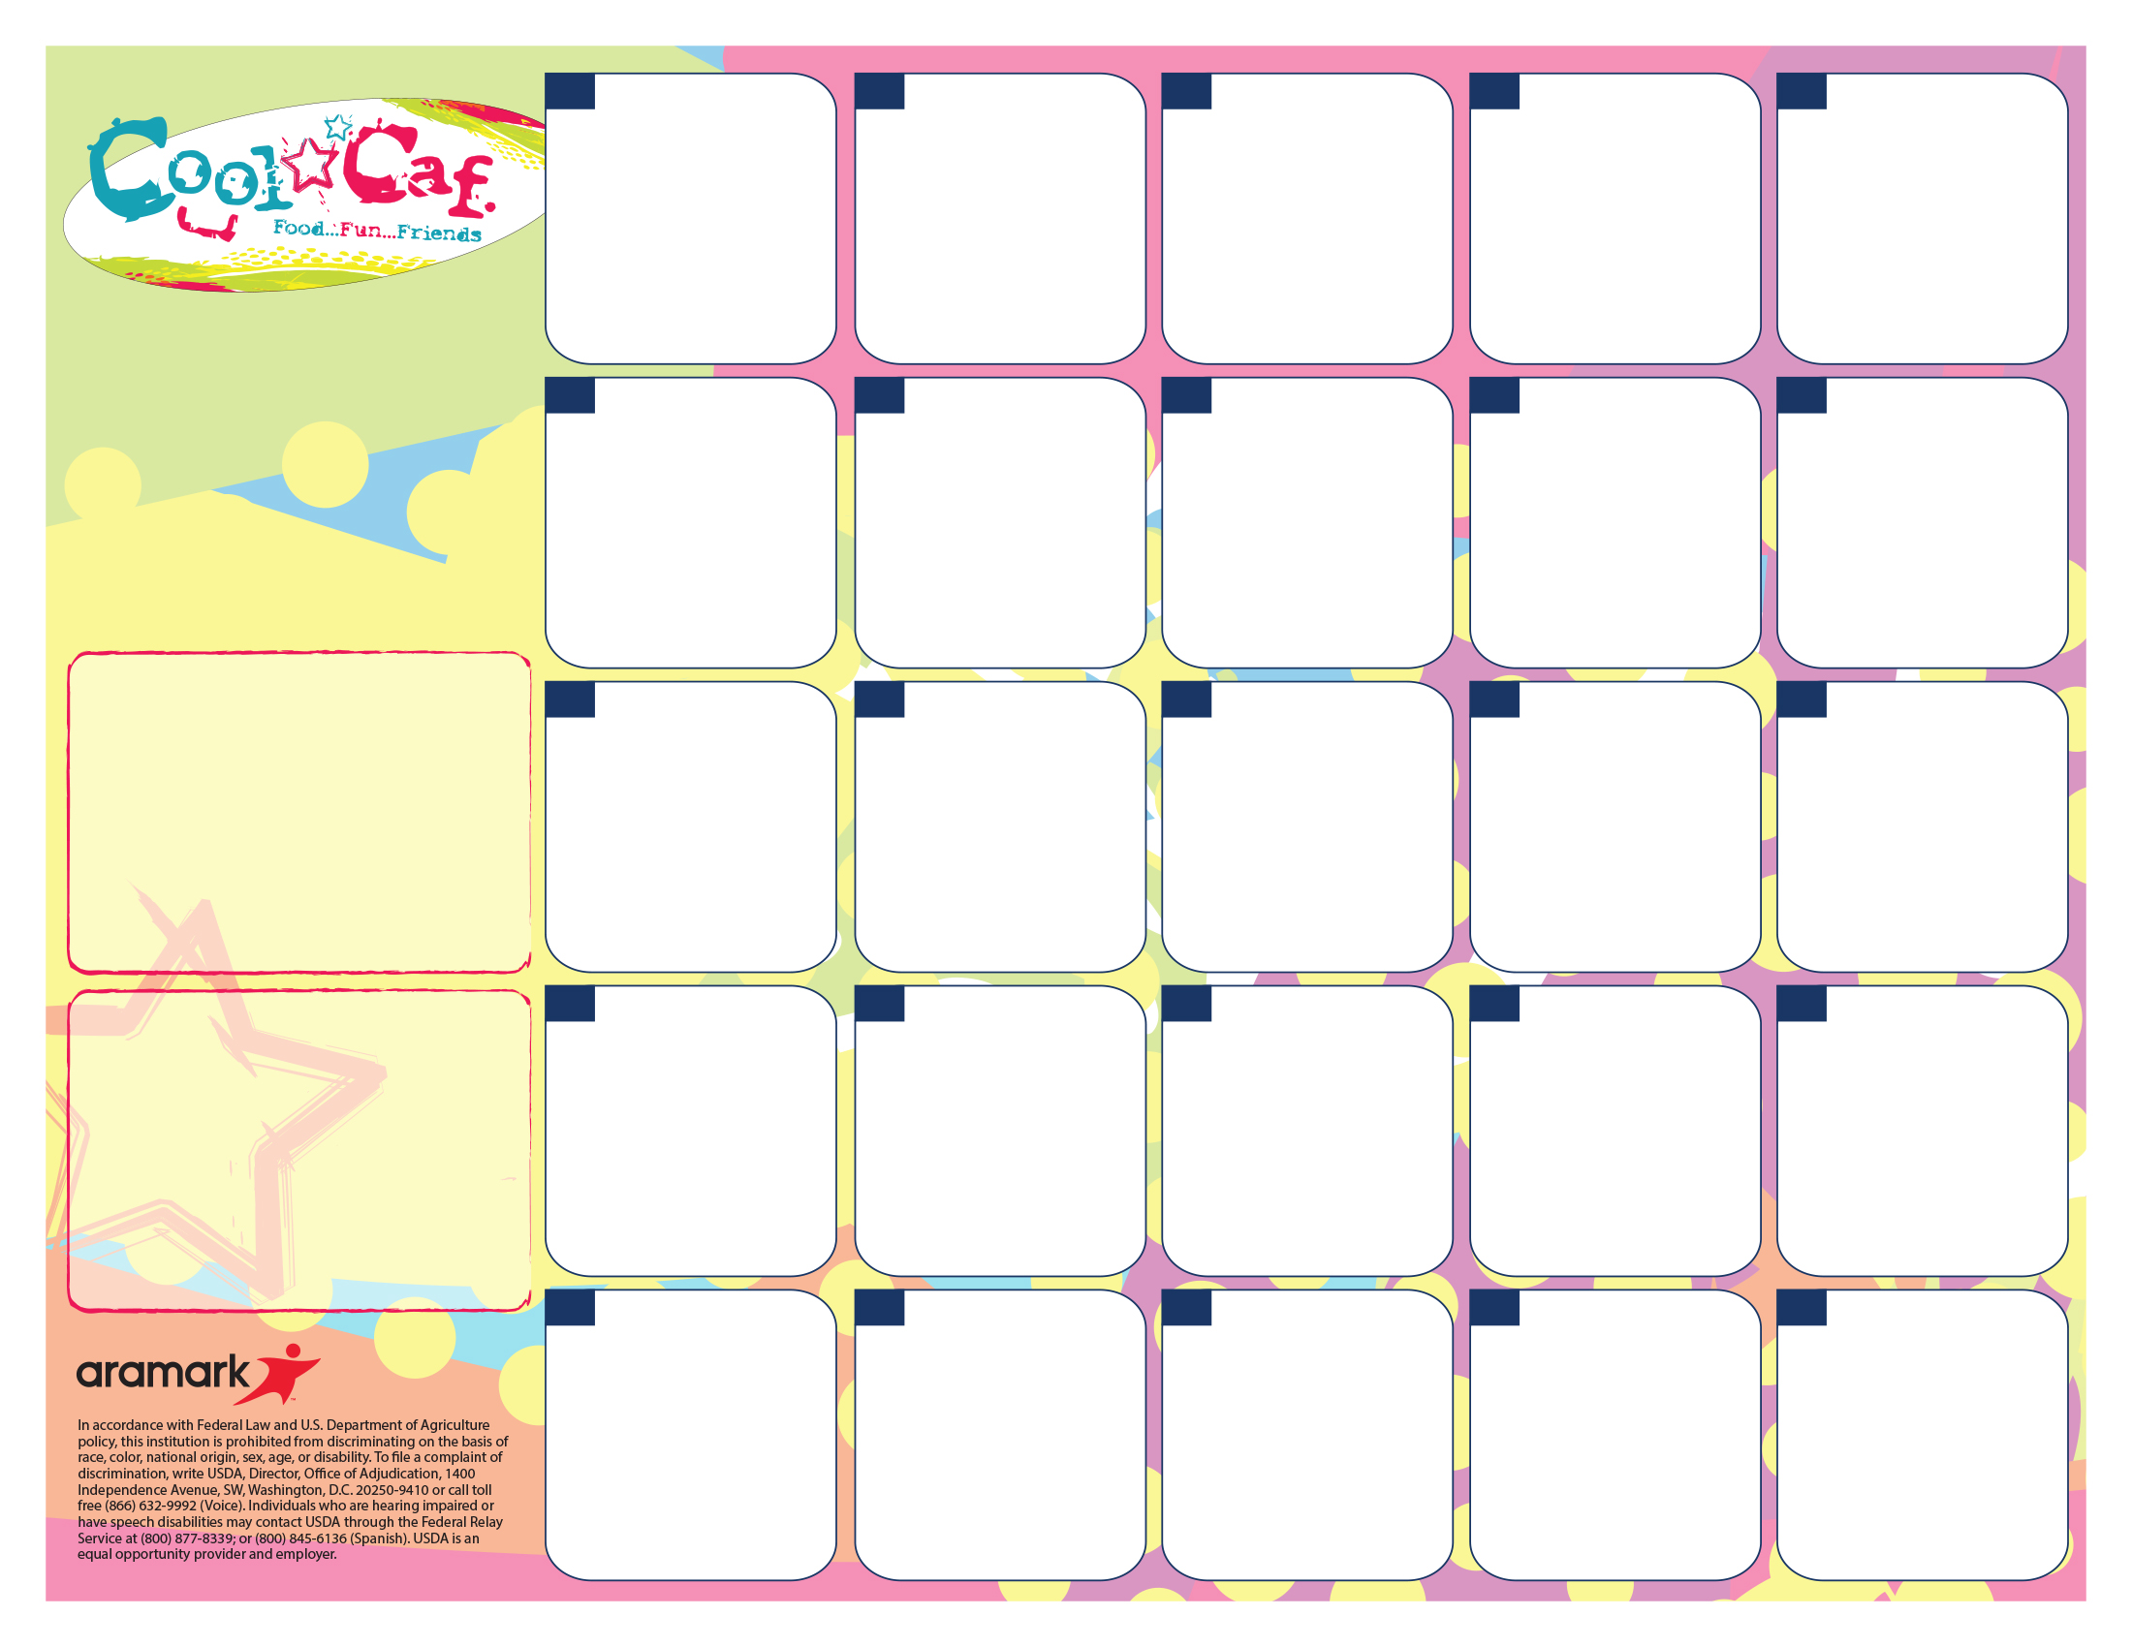

A. Snow Man Pretzel & Soup

B. Pizza

C. Healthy Choice

D. PB&J

Green Beans

Fruit & Veggie BAr

A. Penne & Meat sauce w/garlic toast

B. Pizza

C. Healthy Choice

D. PB&J

California Blend

Fruit &Veggie Bar

**23**

A. Chicken Nuggets

B. Pizza

C. Healthy Choice

D. PB&J

Mashed Potatoes & Gravy with Roll

Fruit & Veggie Bar

**Rice Krispie Giveaway**

**21**

A. Sausage Pancake on Stick

B. Pizza

C. Healthy Choice

D. PB&J

Hash brown

Fruit & Veggie Bar

**20**



**2**

No

School

**1**

A. Chicken Sandwich

B. Ham & Cheese

C. Healthy Choice

D. PB&J

Fruit & Veggie Bar

***Pre Order on the 13th***

**14**

A. Pizza

B. Chicken Patty Sandwich

C. Healthy Choice

D. PB&J

Corn

Fruit & Veggie Bar

**22**

A. Walking Taco

B. Corndog

C. Healthy Choice

D. PB&J

Refried Beans

Fruit & Veggie Bar

**16**

A. Pizza

B. Chicken Sandwich

C. Healthy Choice

D. PB&J

Corn

Fruit & Veggie Bar

**30**

**31**

A. Nachos

B. Chicken Sandwich

C. Healthy Choice

D. PB&J

Refried Beans

Fruit & Veggie Bar

A. Pancakes & Sausage

B. Pretzel w/cheese

C. Healthy Choice

D. PB&J

Hash brown

Fruit & Veggie Bar

**6**

**LUNCH PRICES!**

Lunch

K-5th $2.35

6-8th $2.60

Reduced $.40

Milk/Juice Ala Carte $.50

**Fat free milk, low fat milk, or 100% juice included with each meal.**

A. Rotini & Meat sauce w/garlic toast

B. Pretzel w/cheese

C. Healthy Choice

D. PB&J

Broccoli

Fruit &Veggie Bar

**Cookie Giveaway**

**9**

A. Mini Corn Dogs

B. Chicken Patty

C. Healthy Choice

D. PB&J

Baked Beans

Fruit & Veggie Bar

***31***

**24**

No

School

**3**

A. Mac N Cheese & Garlic toast

B. Corndog

C. Healthy Choice

D. PB&J

Broccoli

Fruit & Veggie Bar

**17**

A. Chicken Smackers

B. Pretzel w/cheese

C. Healthy Choice

D. PB&J

French Fries

Fruit & Veggie Bar

**7**

**1**

A. Chicken Smackers

B. Chicken Sandwich

C. Healthy Choice

D. PB&J

French Fries

Fruit & Veggie Bar

**28**

A. Hot Dog

B. Pretzel w/cheese

C. Healthy Choice

D. PB&J

Tater Tots

Fruit & Veggie Bar

**10**

**=**

A. Variety Pizza

B. Corndog

C. Healthy Choice

D. PB&J

Corn

Fruit & Veggie Bar

**15**

A. French Toast Sticks & Sausage

B. Chicken Sandwich

C. Healthy Choice

D. PB&J

Hash brown

Fruit & Veggie Bar

**27**

Enjoy Your Break

See You Jan 7th

**29**

A. Variety Pizza

B. Pretzel w/cheese

C. Healthy Choice

D. PB&J

Corn

Fruit & Veggie Bar

**8**

Go to [www.sendmoneytoschool.com](http://www.sendmoneytoschool.com)

To view or deposit money into your child’s lunch account.

**\*NO FEE IN JANUARY**

A. Waffle Bar & Sausage Patty

B. Corndog

C. Healthy Choice

D. PB&J

Hash brown

Fruit & Veggie Bar

***Pre Order for the 14th***

**13**

Go to [www.sendmoneytoschool.com](http://www.sendmoneytoschool.com) to view or deposit money to your child’s account.

Go to:

[**www.lunchapp.com**](http://www.lunchapp.com) to apply for Free/Reduced Meals.

**Dutton Christian South Campus Lunch Menu**

**January 2020**